# Introduction

Renewable energy systems, such as solar panels and wind turbines face operational and maintenance challenges that significantly impact their efficiency and reliability [1], [2]. Regular maintenance and unscheduled repairs of these renewable systems are not only expensive but also incur major downtime, which reduces their overall performance for energy production and economic viability [3]. Predictive maintenance has emerged as an effective way to minimise these challenges by anticipating equipment breakdowns before they occur, thus optimising maintenance schedules and reducing downtime of systems [4].

The concept of digital twins, which are dynamic virtual representations of physical systems enabling real-time data analysis and predictive forecasting, has emerged as an evolutionary tool for optimising predictive and descriptive maintenance strategies in renewable energy systems, enhancing operational efficiency, reducing downtime, and improving reliability [5]. Digital Twins utilise real-time sensor data and advanced predictive analysis to anticipate and forecast the performance and potential failures of the physical systems, providing informed maintenance strategies and informed real-time decision-making in renewable energy systems [6].

Despite combining digital twins with predictive maintenance has shown great potential across various industrial applications [7], extensive research addressing their applications in renewable energy systems is still limited. This crevice offers an opportunity to explore the capabilities and effectiveness of Digital Twins integrated with predictive analysis for renewable energy system maintenance.

The research question for this study is:

“How effective is predictive maintenance, assisted by Digital Twins, helps in detecting anomalies and forecasting failures in renewable energy systems such as solar panels and wind turbines”

# Literature Review

The literature review examines three primary things relevant to this research topic:

1. **Predictive Maintenance in Renewable Energy**

Predictive Maintenance in renewable energy systems has been studied due to its operational challenges and significant cost of downtime and maintenance. Reder, Maik, Yürüşen, Nurseda Y., Melero, Julio J. [4]identified predictive maintenance strategies for wind turbines, highlighting how machine learning algorithms when they are applied with sensor data were successful in predicting failures in key components such as gearboxes and blades. This research highlights that implementing predictive maintenance reduced operational cost, and significant downtime compared to traditional maintenance methods.

Tchakoua, Pierre, Wamkeue, René, Ouhrouche, and Mohand [1] provided a review of condition monitoring and predictive maintenance practices for wind turbines, which highlights the importance of real time data collection and analysis. Additionally, they observed that temperature sensors, vibration monitoring, and sound emission were effective in detecting early signs of maintenance to provide proactive actions.

In solar energy system, [8] illustrates how predictive analytics can be used in solar energy systems to forecast solar panel degradations. Their research demonstrated that predictions made by using machine learning models based on historical and real-time data are precisely accurate to estimate the remaining life of solar photovoltaic modules.

1. **Digital Twin Technology**

The concept of Digital Twin originated in manufacturing but was soon adopted across other industries. [9] defined a Digital Twin as a virtual representation of a physical asset, continuously updating real-time data to stimulate and optimise the performance. They emphasised that the twin enables visualisation, monitoring and forecast how it would behave under different circumstances.

Tao F, Zhang H, Liu A, Nee A [6] expanded on the use of digital twins in complex engineering and smart manufacturing, presenting a framework that integrates simulation models, real-time sensor data, and machine-learning algorithms. According to their research, digital twins could enhance the decision-making process by providing actionable insights on predictive maintenance and asset management.

[7] discusses the broader applications of digital twins, including issues with cybersecurity, model integrity, and data integration. They concluded that the deployment of digital twins depends heavily on the quality of real-time data and the robustness of predictive algorithms embedded in the system.

1. **Integration of Digital Twins and Predictive Maintenance**

The concept of Digital Twin originated in manufacturing but was soon adopted across other industries. [9] defined a Digital Twin as a virtual representation of a physical asset, continuously updating real-time data to stimulate and optimise the performance. They emphasised that the twin enables visualisation, monitoring, and forecast how it would behave under different circumstances.

Schlechtingen M, and Ferreira Santos I [10] used machine learning techniques to estimate maintenance on wind turbines SCADA data in the renewable energy sector. Even if they fully did not create a digital twin, their work set the foundation for implementing a predictive model with real-time predictive analysis.

Despite these advancements, there is still a research gap in the application of full predictive maintenance based on digital twins to renewable energy systems, particularly those that combine renewable (wind, solar, etc) technologies.

# Data and Methods

This research will utilise a dataset collected from an operational digital twin model of renewable energy system, focusing on solar panel and wind turbines. Real-time and historical sensors data are involved in the data acquisition process capturing various operational metrics critical to the performance and maintenance of these renewable energy systems.

The data will include:

* Temperature and Humidity data: Environmental sensors positioned close to wind turbines and solar panels to comprehend the effects on environment stress.
* Power Output Measurement: Captured by grid meters and inverters to monitor the performance of energy generation and identify deviations indicative of potential faults.
* Vibration Analysis Data: Data acquired from accelerometers installed on the panel mount, turbine blades, and nacelles to detect mechanical anomalies.
* Environment Collection Data: This includes wind speed, solar irradiance, and precipitation information gathered through sensors connected with digital twins.

The methodology combines descriptive and predictive analysis:

* Descriptive Analysis: Exploratory Data Analysis (EDA) using statistical summaries and visualisations. Identification of key performance indicators (KPIs) and anomaly detection based on historic trends [11].
* Predictive Analysis: Random Forest [12], Gradient Boost Machines [13], Artificial Neural Networks [14], Linear Regression Model [15] will be deployed, with use of k-fold cross validation and evaluation metrics such as precision, recall, F1-score, and mean squared error (MSE).

Considering their adaptability to overfitting and ability to handle high-dimensional data with non-linear relationships, Random Forest and Gradient Boost models are chosen [12], [13]. Neural networks are chosen due to their potent capacity to model complex iterations particularly in dynamic environment circumstances [14]. Linear Regression Models are included to provide a baseline prediction performance that helps in evaluating the efficiency of more complex models [15].

Machine learning frameworks such as Scikit-Learn and TensorFlow will be used for model development. Python libraries (e.g., Pandas, NumPy, Matplotlib) will be used for data analysis and visualisation.

# Research Schedule

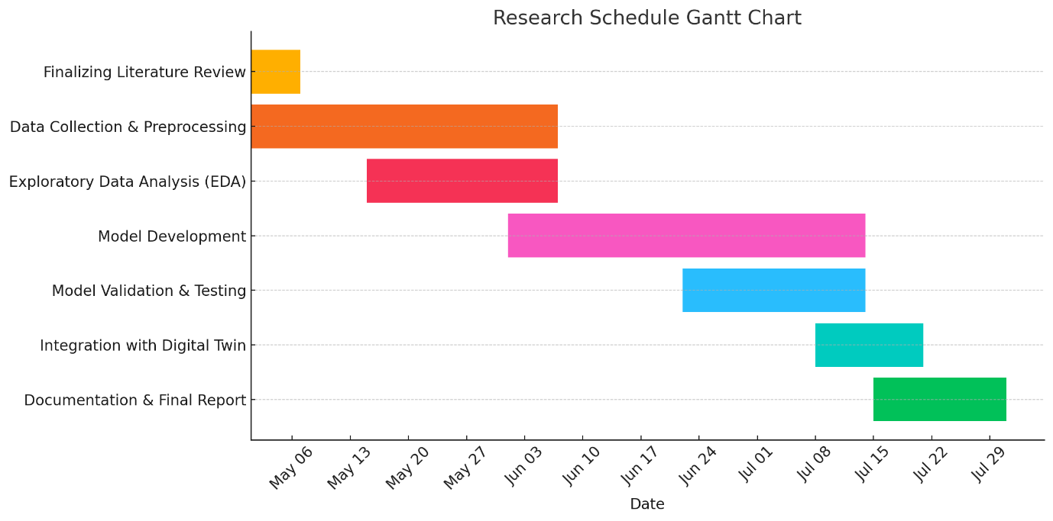

*Fig 1.1 – Gantt Chart for Research Schedule*

# Discussion

Digital Twin technology combined with predictive maintenance techniques has the potential to revolutionize maintenance practices in renewable energy systems [5]. This research, by leveraging real-time data and historical sensor data from solar panels and wind turbines intends to show that predictive models may precisely identify equipment failures and performance degradation before they lead to significant downtime or inefficiencies [4].

The anticipated outcome of this research includes, a longer lifespan for renewable energy systems and significant cost savings are the expected results of this study. By utilising various machine learning algorithms such as Random Forest, Gradient Boost Machines, Neural Networks and Linear Regression to offer comprehensive evaluation of various predictive analysis and their effectiveness when integrated with Digital Twin system.

Furthermore, the research fills in the existing gap in the literature concerning the applications of digital twins in the renewable energy sector. Previous research by [7] has largely focused on predictive maintenance or digital twins individually, with limited integration explored about solar and wind energy systems. This project aims to close that gap by offering empirical support and useful frameworks for practical implementation.

The societal implications are significant: Enhancing renewable energy systems reliability and efficiency aligns with international sustainability objectives, including those outlined by the European Union’s climate action targets. This research supports the broader transition to a cleaner and more robust energy infrastructure by expanding the real-world implementation of predictive maintenance enabled by digital twins.

# Conclusion

This research proposal outlines a large-scale study with the use of digital twin technology for predictive maintenance of renewable energy sources such as wind turbines and solar plants. This research intends to illustrate broad enhancement in operational efficiency, asset longevity, and maintenance cost savings by integrating real-time sensor readings and advanced machine learning algorithms.

By filling the existing gaps in the literature and using predictive analysis in a digital twin network, this study will contribute to actionable insights toward proactive asset management for renewable energy. It will also support global sustainability efforts by providing dependable and scalable energy solutions.

In future work, the scope of this research can be extended to include other renewable energy technologies such as hydroelectric, geothermal, and biomass power plants. Applying predictive maintenance principles to these sources may further accelerate the transition towards a completely robust and sustainable energy framework, and a broader and more impactful contribution to global energy goals.

# Bibliography

[1] P. Tchakoua, R. Wamkeue, M. Ouhrouche, F. Slaoui-Hasnaoui, T. A. Tameghe, and G. Ekemb, “Wind turbine condition monitoring: State-of-the-art review, new trends, and future challenges,” *Energies (Basel)*, vol. 7, no. 4, pp. 2595–2630, 2014, doi: 10.3390/EN7042595.

[2] H. Abdulla, A. Sleptchenko, and A. Nayfeh, “Photovoltaic systems operation and maintenance: A review and future directions,” *Renewable and Sustainable Energy Reviews*, vol. 195, p. 114342, May 2024, doi: 10.1016/J.RSER.2024.114342.

[3] S. Reichelstein and M. Yorston, “The prospects for cost competitive solar PV power,” *Energy Policy*, vol. 55, pp. 117–127, Apr. 2013, doi: 10.1016/J.ENPOL.2012.11.003.

[4] M. Reder, N. Y. Yürüşen, and J. J. Melero, “Data-driven learning framework for associating weather conditions and wind turbine failures,” *Reliab Eng Syst Saf*, vol. 169, pp. 554–569, Jan. 2018, doi: 10.1016/J.RESS.2017.10.004.

[5] J. Vickers and M. Grieves, “Digital Twin: Mitigating Unpredictable, Undesirable Emergent Behavior in Complex Systems,” 2017, doi: 10.1007/978-3-319-38756-7_4.

[6] F. Tao, H. Zhang, A. Liu, and A. Y. C. Nee, “Digital Twin in Industry: State-of-the-Art,” *IEEE Trans Industr Inform*, vol. 15, no. 4, pp. 2405–2415, Apr. 2019, doi: 10.1109/TII.2018.2873186.

[7] A. Fuller, Z. Fan, C. Day, and C. Barlow, “Digital Twin: Enabling Technologies, Challenges and Open Research,” *IEEE Access*, vol. 8, pp. 108952–108971, 2020, doi: 10.1109/ACCESS.2020.2998358.

[8] I. Kaaya *et al.*, “Service Lifetime Prediction of PV Modules and Systems: Progress of the SOLAR-TRAIN Project,” *Conference Record of the IEEE Photovoltaic Specialists Conference*, pp. 1352–1356, Jun. 2019, doi: 10.1109/PVSC40753.2019.8980791.

[9] H. Jiang, S. Qin, J. Fu, J. Zhang, and G. Ding, “How to model and implement connections between physical and virtual models for digital twin application,” *J Manuf Syst*, vol. 58, pp. 36–51, Jan. 2021, doi: 10.1016/J.JMSY.2020.05.012.

[10] M. Schlechtingen and I. Ferreira Santos, “Comparative analysis of neural network and regression based condition monitoring approaches for wind turbine fault detection,” *Mech Syst Signal Process*, vol. 25, no. 5, pp. 1849–1875, Jul. 2011, doi: 10.1016/J.YMSSP.2010.12.007.

[11] John W. Tukey, *Exploratory Data Analysis*. Addison-Wesley, 1977.

[12] L. Breiman, “Random forests,” *Mach Learn*, vol. 45, no. 1, pp. 5–32, Oct. 2001, doi: 10.1023/A:1010933404324/METRICS.

[13] “Greedy Function Approximation: A Gradient Boosting Machine on JSTOR.” Accessed: Apr. 26, 2025. [Online]. Available: https://www.jstor.org/stable/2699986

[14] Y. Lecun, Y. Bengio, and G. Hinton, “Deep learning,” *Nature*, vol. 521, no. 7553, pp. 436–444, May 2015, doi: 10.1038/NATURE14539.

[15] “Linear Regression Analysis - George A. F. Seber, Alan J. Lee - Google Books.” Accessed: Apr. 26, 2025. [Online]. Available: https://books.google.ie/books/about/Linear_Regression_Analysis.html?id=X2Y6OkXl8ysC